Ungaretti, Giuseppe (1888-1970)

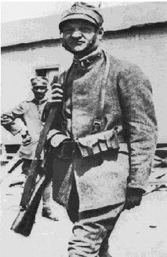
(Ungaretti during World War One: http://en.wikipedia.org/wiki/Giuseppe_Ungaretti)

Giuseppe Ungaretti was a major Italian author of the first half of the Twentieth Century. In his poetry he achieves a massive reinvention of Italian poetic language, abolishing punctuation, dismembering syntax, fragmenting the verse into single verbal unities. Words acquire a completely new relevance and density, which counterweigh the abundance of silence and blank space, in line with the symbolist model of Mallarmé.

Born in Alexandria in Egypt in 1888, Ungaretti received a bilingual education in both Italian and French. After moving to Paris in 1912, he became part of Parisian intellectual and poetic life, attended classes at the Sorbonne, and came into contact with all major cultural personalities of the time, such as Henri Bergson, Guillaume Apollinaire, Pablo Picasso, and the Italian futurists, among others. With Italy’s entry into World War One, Ungaretti volunteered as a soldier in the northern Italian region of Carso from 1915 to 1916, an experience that intensely affected his poetic production, and which he conveyed in his first book of poems, Il Porto Sepolto (The Buried Harbor), published in 1916. The title’s image of the buried harbor refers to a hidden inner dimension to be explored by the poet, while the central theme of the book is the experience of the war, during which Ungaretti was exposed to the brutal death of fellow soldiers in the trenches. The aridity of the landscape is paired with the contemplation of death and the nullity of human beings, which triggers a cosmic attachment to life, as in the poem “Veglia” (“Vigil”). The Buried Harbour was subsequently incorporated in the collection L’allegria (Joy), published in 1931, a paradoxical title for a book which, in poems such as “Soldati” (“Soldiers”), focuses on the experience of war and human frailty.
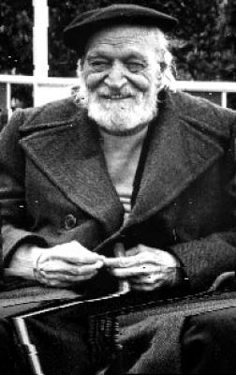
(http://www.athenamillennium.it/letteratura/Giuseppe_Ungaretti.html)

At the beginning of the 1920s, after moving to Rome, Ungaretti’s poetry embraced more classicist patterns, displayed in the book of poems Sentimento del tempo (A Sense of Time), written between 1919 and 1933. Here memory and tradition are present both as formal guidelines (especially with a return to metric patterns) and as themes of the poems (many of which are mythological in their inspiration). In the 1930s Ungaretti moved to Brasil to teach Italian literature in Sao Paolo. Tragic events in the poet’s life, and the start of the Second World War, lead to the writing of the book of poems Il dolore (Affliction), between 1937 and 1946. The violent beauty of the tropical landscape affected Ungaretti’s poetic imagery, which through baroque patterns of syntax and vocabulary conveys a tragic sense of life and despair when faced with human insubstantiality. With his last book of poems, La terra promessa (The Promised Land), thematically inspired by Virgil’s Aeneid and published in 1950, Ungaretti returned to a more sober cadence, which characterized his poetry in the last decade of his life. During this period Ungaretti wrote increasingly lapidary poems, sharing in what can be seen as the European post-war poetics of aphasia, the poetry of silence also visible in poets such as Henri Michaux and Paul Celan.

References and further reading

Collections

Ungaretti, G. (1969), Vita d’un uomo: Tutte le poesie. Milano: Mondadori.
Ungaretti, G. (1974), Vita d’un uomo: Saggi e interventi. Milano: Mondadori.
Ungaretti, G. (2000), Vita d’un uomo: Viaggi e lezioni. Milano: Mondadori.

Translations

Ungaretti, G. (1975), Selected Poems of Giuseppe Ungaretti. Ithaca: Cornell University Press.

Further readings

Cambon, G. (1967), Giuseppe Ungaretti. New York: New York University Press.
Ossola, C. (1982), Giuseppe Ungaretti. Milano: Mursia.

External links

Ungaretti reads his poem Sono una creatura and speaks of his poetic influences
http://www.rai.tv/dl/RaiTV/programmi/media/ContentItem-e0f7d766-08e8-4933-aeb3-6ff47fee460a.html

Ungaretti reads his poem I fiumi
http://www.rai.tv/dl/RaiTV/programmi/media/ContentItem-5ea17145-cd15-4511-82c6-b223e127910e.html

For more links to videos with Ungaretti:
http://www.rai.tv/dl/RaiTV/ricerca.html?q=ungaretti&sort=date:D:L:d1&filter=0&getfields=*&site=raitv&start=10

